WORKSHEET 1
Taguchi Analysis: RMS versus Tool diameter, Step over, Spindle speed, Feed rate, Temperature

Response Table for Signal to Noise Ratios
Smaller is better
Level | Tool  diameter | Step over | Spindle  speed | Feed rate | Temperature
1 | -19.44 | -19.44 | -19.44 | -19.44 | -19.44
2 | -19.44 | -19.44 | -19.44 | -19.44 | -19.44
3 | -19.44 | -19.44 | -19.44 | -19.44 | -19.44
4 | -19.44 | -19.44 | -19.44 | -19.44 | -19.44
Delta | 0.01 | 0.00 | 0.00 | 0.00 | 0.00
Rank | 1 | 5 | 3 | 4 | 2
Response Table for Means
Level | Tool  diameter | Step over | Spindle  speed | Feed rate | Temperature
1 | 9.373 | 9.376 | 9.375 | 9.376 | 9.377
2 | 9.376 | 9.376 | 9.377 | 9.376 | 9.375
3 | 9.378 | 9.377 | 9.376 | 9.377 | 9.376
4 | 9.378 | 9.376 | 9.378 | 9.377 | 9.378
Delta | 0.005 | 0.001 | 0.002 | 0.001 | 0.002
Rank | 1 | 5 | 3 | 4 | 2
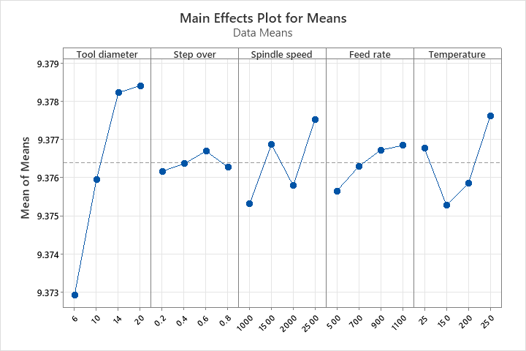
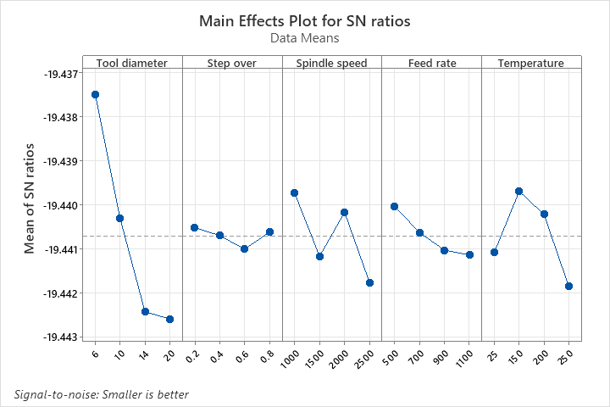

WORKSHEET 1
Regression Analysis: RMS versus Tool diameter, Step over, Spindle speed, Feed rate, Temperature

Regression Equation
RMS | = | 9.36756 + 0.0003884 Tool diameter + 0.00033 Step over + 0.000001101 Spindle speed  + 0.00000201 Feed rate + 0.00000171 Temperature
Coefficients
Term | Coef | SE Coef | T-Value | P-Value | VIF
Constant | 9.36756 | 0.00281 | 3334.90 | 0.000
Tool diameter | 0.000388 | 0.000088 | 4.40 | 0.001 | 1.00
Step over | 0.00033 | 0.00204 | 0.16 | 0.874 | 1.00
Spindle speed | 0.000001 | 0.000001 | 1.35 | 0.207 | 1.00
Feed rate | 0.000002 | 0.000002 | 0.98 | 0.348 | 1.00
Temperature | 0.000002 | 0.000005 | 0.31 | 0.760 | 1.00
Model Summary
S | R-sq | R-sq(adj) | R-sq(pred)
0.0018243 | 69.05% | 53.58% | 26.07%
Analysis of Variance
Source | DF | Adj SS | Adj MS | F-Value | P-Value
Regression | 5 | 0.000074 | 0.000015 | 4.46 | 0.021
Tool diameter | 1 | 0.000065 | 0.000065 | 19.40 | 0.001
Step over | 1 | 0.000000 | 0.000000 | 0.03 | 0.874
Spindle speed | 1 | 0.000006 | 0.000006 | 1.82 | 0.207
Feed rate | 1 | 0.000003 | 0.000003 | 0.97 | 0.348
Temperature | 1 | 0.000000 | 0.000000 | 0.10 | 0.760
Error | 10 | 0.000033 | 0.000003
Total | 15 | 0.000108
